**EXP 7**

**Feedback Food App – UI/UX Experimentation and User Feedback Documentation**

**Objective**

The goal of this project is to design and experiment with various layout styles and color schemes for a food feedback mobile application. Using Figma, multiple prototypes were created to assess the impact of visual and structural differences on user experience. User feedback was collected to evaluate aesthetics and usability, helping to determine the most effective design approach.

**Methodology**

**1. Design Phase**

* **Created Multiple Variants:**
  + Different layout structures (grid-based, list-based, card-based).
  + Varied color themes (bright and vibrant, pastel and soft, dark mode).
  + Alternate typography and iconography styles.
* **Prototyping in Figma:**
  + Interactive flows were designed for key tasks: rating food, submitting feedback, viewing rewards.
  + Hotspots and transitions were added to simulate real user interactions.

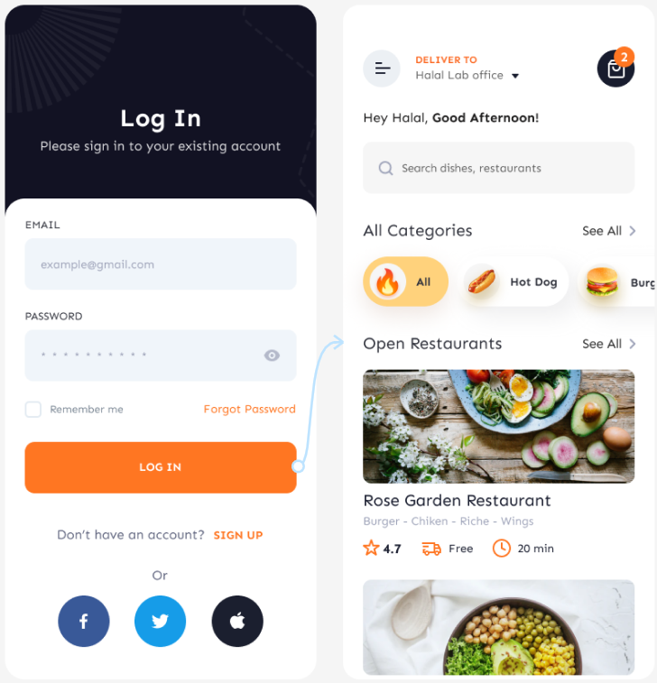

**2. User Testing Phase**

* **Target Audience:**  
  Regular restaurant-goers and food delivery app users.
* **Testing Tools:**  
  Figma prototype sharing + feedback form (Google Forms or Figma Comments).
* **Test Activities:**
  + Explore different UI versions.
  + Complete common tasks (submit feedback, rate food).
  + Answer post-test survey on visual appeal, ease of use, and preference.

**3. Feedback Collection**

* **Survey Questions Included:**
  + Which color scheme felt more inviting?
  + Was the navigation intuitive?
  + Which layout felt more comfortable to use?
  + Any specific suggestions for improvement?
* **Feedback Methods:**
  + Direct comments on Figma designs.
  + Online survey with quantitative (rating scale) and qualitative (open-ended) questions.
  + Short interviews for detailed insights.

**Analysis & Key Findings**

* **Visual Preferences:**  
  Users preferred lighter, food-themed color palettes with clean layouts for easier readability.
* **Usability Insights:**  
  Simpler navigation structures (bottom navigation bar) were rated higher for quick access compared to complex layered menus.
* **Improvement Areas:**  
  Some users suggested adding visual cues (highlighted buttons, subtle animations) to guide actions like submitting feedback.

**Conclusion**

Through systematic experimentation and real user input, the project identified the optimal combination of a light, clean design with a straightforward, card-based layout for the food feedback app. Future iterations will incorporate more personalization features based on user preferences.